TEACHERS’ NOTES
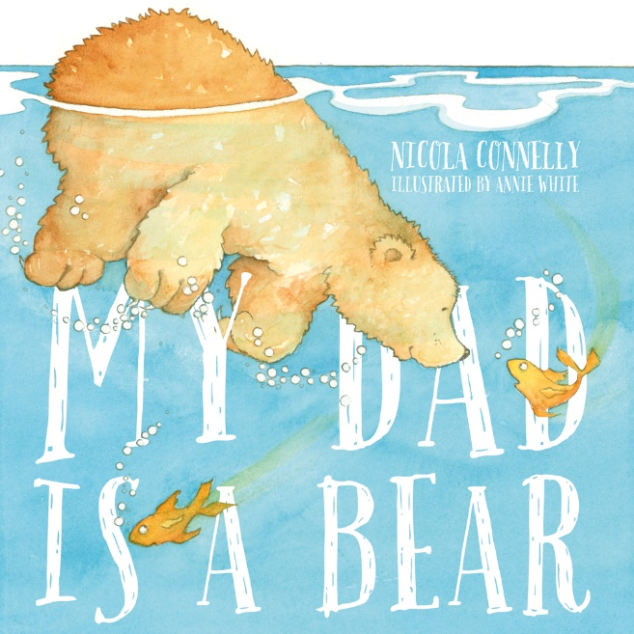
www.newfrontier.com.au/teachers/category/all/

My Dad is a Bear
Written by Nicola Connelly
Illustrated by Annie White
Synopsis
Charlie's dad is tall, round and soft. Sometimes he growls. Could he be a bear? Luckily for Charlie there's one thing bears do best.

Author Motivation
Nicola enjoys creating stories that are simple, heart-warming and encourage family bonding time. The motivation for Nicola was to write a simple yet descriptive story for young children to read independently and enjoy with their family. She enjoys writing text that is at an achievable level for young children to take ownership of their reading and develop confidence. Nicola has a firm belief in the importance of encouraging children to begin reading from a young age and to inspire children to find the joy in reading. The main inspiration for the story was Nicola’s Dad who often demonstrates many bear characteristics. Nicola’s family and students provide lots of good ideas and inspiration for her future stories.

Author Background Information
Nicola Connelly is an emerging Australian author. The stories that she writes are based on real life experiences and those she likes to read now and when she was a child. She is a primary school teacher with a passion for writing children’s books. Over the last five years Nicola has been teaching primary school children in both Queensland and Victoria. Nicola loves working with children and very much enjoys reading rich literature to her students. She realised the potential children’s book have for teaching and the positive learning effect they had on her students and so she began to study different authors, often as an author study with her students. With her students, she appreciated stories by Jeannie Baker, Mex Fox, Jackie French, Graeme Base, Alison Lester and Pamela Allen. Nicola’s first book, ‘My Dad is a Bear’ was published by New Frontier Publishing in 2014. This story of a very cuddly looking bear was listed as a Children’s Book Council of Australia (CBCA) Notable Book for 2015 and shortlisted for the Prime Minister Literary Awards 2015.

Illustrator Background Information
Annie grew up in Geelong. Her childhood was spent on the beaches along the Great Ocean Road, climbing very tall trees, delighting in the worlds of A. A. Milne, The Magic Faraway Tree and Alice in Wonderland and drawing endlessly at the kitchen table.
After studying Art and Design, she worked in advertising and then became a full time Illustrator.
Annie’s favourite kind of work is illustrating books for children but her drawings have also been turned into jigsaw puzzles, stamps, stencils, magazines and murals.
Recently, Annie has also begun to write and her first book, Clementine’s Walk, was shortlisted in the Speech Pathologist’s Awards.
Two of her picture books, Mbobo Tree (Glenda Millard) and My Dad Is A Bear (Nicola Connelly), have been listed as CBCA Notable books. My Dad Is A Bear was also short listed in the Prime Minister’s Literary Awards.

Illustrator Style or Medium
Annie used watercolour and pencil to illustrate the story of My Dad Is A Bear. She created the rabbit and the bluebird to help support the sizeable but gentle bear as he fishes and sleeps and growls his way through the pages of this book.

Educational Applicability
The key themes in this book is descriptive language and comparison. It has great potential as a writing prompt to write about family members and how they could be described as animals exhibiting animal characteristics.

DISCUSSION TOPICS
Before and during reading the book:
- Introduce the book – read the title and ask who may the names of the front cover represent. Read the author and illustrator’s name. Mention you have heard the name Annie White before because she has illustrated other books such as Gallipoli and authored and illustrated other books such as ‘Clementine’s Walk’ and ‘Clementine’s Bath’. Take a look here
- Ask students what they think this book will be about? Who do they think the characters are? Is the book about animals or people?
- As you read the book emphasise the descriptive language used.

After reading the book:
- Ask children what they thought about the ending. Did they enjoy the story? Would they have recommended it to someone else? Out of five stars, what would they rate it?
- Ask students for a show of hands of those who think their dad may be like a bear? Does anyone think their dad may be like a different animal?
- Encourage participation … Ask are there other members of their family that remind them of particular animals? How would they describe them?

ACTIVITIES
Writing Prompts
‘My Dad is a Bear’ is a great writing prompt to encourage children to write about their own Dads. Written below are some examples of sentence starters to get students writing. These prompts are more likely suited for lower primary years.
I think my dad is a bear because …
I think my dad is like a _________ because …
The Bear in ‘My Dad is a Bear’ makes me think of my dad because…
I think my__________ is like a ___[animal}_____becaus e…
Charlie’s dad was important to him. My dad is important to me because…

Writing Ideas
Ask students to draw a picture of their dad either as they are or what animal they think their dad most remind them of. Ask students to write interesting words around the picture of their dad that best describe him.

Art and Craft Activities
Paper Plate Bear
This an easy yet engaging activity for students to do. They will love to take this home and show their family. Using cut out white circles and paper plates, students paint on their desired brown colour. Students cut circles out of pink paper for the ears and black circles for the eyes and nose. Using light brown paper students cut out a nose as seen below. Stick all circles down using glue. Students complete the nose using a black texter.

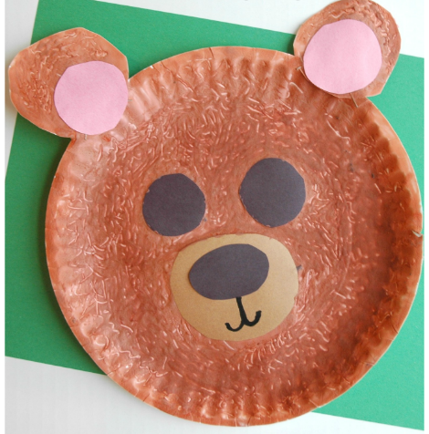

Hand Print Activity

Model drawing a bear’s face. The simplest way to do it, is to draw a circle first using a grey lead pencil then add in ears and a slit for the mouth. Students draw their own version of bear’s face on brown paper and cut it out. Using a black texter colour in a nose and draw two black eyes. For the body of the bear students paint their hand with brown paint and press it onto white paper. When the handprint is dry students flip the paper around and glue down their already made bear face onto their thumb.

Illustrator/Author Study:
If you are studying an author or looking for illustration inspirations, find some other books illustrated and written by Annie White in your school library. Ask prompting questions such as:
Are the illustrations similar to her other books?
What medium does Annie White use to create her images?
Explore some of the books she has written. Take a look here

MARKETING AND SELLING POINTS
- ‘My Dad is a Bear’ is worded simply for early readers.
- Great story for Father’s Day.
- Annie White a highly regarded illustrator, she brings the Bear to life with endearing illustrations.
- The book was recognised as a Notable book in 2015 by the Children’s Book Council of Australia and shortlisted for the 2015 Prime Minster Literary Awards.

